Pimpri Chinchwad Education Trust’s
PIMPRI CHINCHWAD COLLEGE OF ENGINEERING
(An Autonomous Institute affiliated to Savitribai Phule Pune University)
DEPARTMENT OF INFORMATION TECHNOLOGY

MINI PROJECT REPORT
on
“EventPulse — Campus Event Management System”
Submitted by
Sr. No. | Name | PRN Number | Class & Division
1 | Parth Patil | 123B1F073 | TY – B
2 | Yashraj Rajapure | 123B1F081 | TY – B
3 | Sharddha Utpat | 123B1F098 | TY – B

Academic Year: 2025–26

TABLE OF CONTENTS
Sr. No. | Content | Page No.
1 | Introduction  1.1 Background  1.2 Problem Statement  1.3 Objectives
2 | Frontend Development  2.1 UI/UX Design  2.2 Components and Structure  2.3 Routing and Navigation  2.4 Responsiveness  2.5 State Management and API Handling  2.6 Additional Features
3 | Backend Development  3.1 Spring Boot Architecture  3.2 REST API Design  3.3 Business Logic Implementation  3.4 Database Configuration  3.5 CRUD Operations Implementation  3.5.1 Create Operation  3.5.2 Read Operation  3.5.3 Update Operation  3.5.4 Delete Operation  3.6 Role-Based Access Control (RBAC)
4 | Authentication & Security  4.1 User Registration and Login  4.2 Validation Techniques  4.3 Security Measures
5 | Frontend–Backend Integration  5.1 API Integration (Axios/Fetch)  5.2 Data Flow Mechanism  5.3 Error Handling
6 | Deployment  6.1 Deployment Platform  6.2 Deployment Steps  6.3 Live Application URL
7 | Testing and Validation  7.1 API Testing (Postman)  7.2 Unit Testing (JUnit/Mockito)  7.3 Test Cases and Results
8 | Results and Discussion (Screenshots of website)
9 | Conclusion
10 | References

1. Introduction
1.1 Background
EventPulse is a full-stack web application designed to digitize and automate the complete lifecycle of college events. In traditional systems, event management is handled manually using paperwork, spreadsheets, and informal communication channels such as emails and messaging applications. These methods are inefficient and often lead to miscommunication, delays, and lack of proper coordination among different stakeholders. As the number of events increases in an institution, managing approvals, registrations, and attendance becomes increasingly complex. There is also a lack of centralized tracking, making it difficult to monitor event progress and maintain accurate records. EventPulse addresses these challenges by providing a centralized, role-based, and automated platform. It enables structured workflows, improves communication, and ensures transparency at every stage of the event lifecycle. By integrating modern web technologies, the system enhances efficiency and provides a better user experience for all stakeholders.

1.2 Problem Statement
The existing manual event management system suffers from several limitations:
- Lack of a structured approval workflow across multiple authorities
- Difficulty in tracking event progress and approval status
- Redundant communication leading to delays and confusion
- Absence of centralized data storage for events and participants
- No real-time analytics or reporting system
- Increased chances of data inconsistency and human errors
These issues highlight the need for a robust and automated solution that can streamline event management processes, ensure proper coordination, and provide real-time insights.

1.3 Objectives
The primary objectives of the EventPulse system are:
- To digitize and automate the entire event lifecycle
- To implement a multi-stage approval workflow involving Faculty, SDW, and HoD
- To provide role-based access control (RBAC) for different users
- To enable easy and efficient event registration for students
- To maintain centralized and secure data storage
- To provide an analytics dashboard for monitoring and decision-making
- To improve transparency, efficiency, and accountability in event management

2.Frontend Development
2.1 UI/UX Design
The frontend of EventPulse is developed using React 18, a modern JavaScript library for building user interfaces, along with Tailwind CSS, a utility-first CSS framework. The design focuses on simplicity, clarity, and usability, ensuring that users from different roles can interact with the system efficiently.
The application provides role-based dashboards for five different types of users:
- Student
- Organizer
- Faculty Advisor
- SDW Coordinator
- Head of Department (HoD)
Each role has a customized interface displaying only the relevant features and data. For example, students can browse and register for events, while faculty and higher authorities can review and approve event proposals.
The UI uses:
- Color-coded status badges (e.g., approved, pending, rejected)
- Clean card layouts for event display
- Structured forms for event creation and approvals
- Consistent spacing and typography using Tailwind CSS
This results in a visually appealing and user-friendly interface.

2.2 Components and Structure
The frontend follows a component-based architecture, which improves code reusability, scalability, and maintainability. Each part of the UI is divided into reusable components.
Key Components:
- Sidebar Component
The Sidebar provides navigation links based on the user’s role. It dynamically changes menu options such as Dashboard, Events, Approvals, Reports, and Analytics.
- Dashboard Layout
A common layout component is used across all pages. It includes:
- Sidebar (navigation)
- Header (title and user info)
- Main content area
This ensures consistency in UI design.

- EventCard Component
Displays event details such as:
  - Event title
  - Date and time
  - Status (e.g., pending, approved)
  - Registration button
It is mainly used in student dashboards and event browsing pages.

- WorkflowBadge Component
This component visually represents the event approval workflow: Faculty
→ SDW → HoD
It highlights:
  - Completed steps (green)
  - Current stage (highlighted)
  - Pending stages (grey)
This helps users easily understand the status of an event.

- ApprovalModal Component
Used by faculty, SDW, and HoD to:
  - Approve or reject events
  - Add comments
This ensures structured decision-making.
- EventDetailDrawer
A side panel that shows detailed event information when selected. It includes:
  - Event description
  - Budget details
  - Coordinator information
  - Approval comments (visible only to staff)

2.3 Routing and Navigation
The application uses React Router (v6) for client-side routing, enabling smooth navigation without page reloads.
A Guard component is implemented for route protection. It checks:
  - Whether the user is logged in
  - Whether the user has the correct role
If these conditions are not met, the user is redirected to the login page. This ensures that unauthorized users cannot access restricted pages.
Routes are defined for:
  - Public pages (Home, Login, Signup)
  - Protected dashboards (Student, Organizer, Faculty, SDW, HoD)

2.4 Responsiveness
The frontend is designed to be fully responsive using Tailwind CSS. The layout adapts to different screen sizes using:
  - Flexible grid systems
  - Responsive utility classes
  - Adaptive components
This ensures that the application works smoothly on:
  - Mobile devices
  - Tablets
  - Desktop systems

2.5 State Management and API Handling The frontend uses React hooks such as:
  - useState for managing component state
  - useEffect for handling lifecycle events
API communication is handled using Axios, which sends HTTP requests to the backend. JWT tokens are attached to requests for authentication.
Data received from APIs is dynamically rendered on the UI, ensuring real-time updates of event status and user actions.

2.6 Additional Features
The frontend includes several advanced features that enhance usability:
  - Search and Filtering: Users can search events and filter based on categories or status
  - Dynamic Dashboards: Each role sees customized data and options
  - Real-time Status Updates: Event status updates are reflected immediately
  - Analytics Dashboard: Graphs and charts (using Recharts) display insights such as event trends and approvals
  - Form Validation: Ensures correct data entry before submission
These features make the system interactive, efficient, and user-friendly.

3.Backend Development
3.1 Spring Boot Architecture
The backend of EventPulse is developed using Spring Boot 4, which provides a robust framework for building scalable and production-ready applications. The system follows a layered architecture, ensuring proper separation of concerns and modular design.
The architecture consists of the following layers:
- Controller Layer: Handles incoming HTTP requests and sends appropriate responses using REST APIs.
- Service Layer: Contains the core business logic, including event workflow management and validation rules.
- Repository Layer: Uses Spring Data JPA to perform database operations.
- Model Layer: Defines entity classes such as User, Event, Registration, and Attendance.
The application uses constructor-based dependency injection, which improves testability and ensures loose coupling between components.

3.2 REST API Design
The backend exposes a set of RESTful APIs that enable communication between frontend and backend systems. These APIs follow standard HTTP methods and REST principles.
Major API Modules:
- Authentication APIs o User registration (signup) o User login (JWT-based authentication)
- Event APIs o Create event o Update event details o Fetch all events o
Fetch events by status
- Approval APIs o Faculty review o SDW review
o HoD final approval
- Registration APIs o Student event registration o Check duplicate registrations o Count registrations per event
- Attendance APIs o Mark attendance o Retrieve attendance records
Each API returns structured JSON responses and uses appropriate HTTP status codes such as 200 (success), 400 (bad request), and 401 (unauthorized).

3.3 Business Logic Implementation (State Machine)
The core functionality of EventPulse is implemented using a state machine-based workflow that controls the event approval process.
Event Lifecycle States:
- PENDING_FACULTY
- PENDING_SDW
- PENDING_HOD
- APPROVED
Workflow Behavior:
- An event starts in PENDING_FACULTY state.
- It passes through Faculty → SDW → HoD approval stages.
- At any stage, the event can be approved or rejected.
- If rejected, the event is sent back to the organizer for modification and the process restarts.
The backend strictly validates all state transitions. If an invalid transition is attempted, the system rejects the request, ensuring workflow integrity.
The system enforces all workflow transitions at the server level, ensuring that invalid state changes are rejected even if APIs are accessed directly.

Stage | Description
PENDING_FACULTY | Event submitted by organizer
PENDING_SDW | Waiting for SDW approval
PENDING_HOD | Waiting for HoD approval
APPROVED | Event is live for students

3.4 Database Configuration
The backend uses PostgreSQL (Supabase) as the database management system. Hibernate ORM is used to map Java objects to relational tables.
Core Tables:
- Users Table
Stores user-related information:
      - Unique email and encrypted password
      - Role (Student, Organizer, Faculty, SDW, HoD)
      - Department and additional attributes
- Events Table
Stores event details:
      - Event title, description, and schedule
      - Approval status
      - Budget and department information
      - Organizer details
- Registrations Table
      - Links students to events
      - Prevents duplicate entries using unique constraints
- Attendance Table
      - Tracks attendance for each registered student
      - Maintains one record per registration
Foreign key relationships ensure referential integrity between tables.

Table Name | Purpose
Users | Stores user details and roles
Events | Stores event details and approval status
Registrations | Links students with events
Attendance | Tracks attendance of registered users

3.5 CRUD Operations Implementation
The backend supports full CRUD functionality for managing event data.
3.5.1 Create
      - Organizers can create new events
      - Students can register for events
      - Attendance records can be created
3.5.2 Read
      - Retrieve event details
      - Fetch lists of events and registrations
      - View attendance and analytics data
3.5.3 Update
      - Update event details and status
      - Modify attendance records
      - Process approval decisions
3.5.4 Delete
      - Remove events or registrations when necessary
      - Maintain data consistency

3.6 Role-Based Access Control (RBAC)
The system implements Role-Based Access Control to ensure that users can only perform actions permitted by their role.
Roles:
      - Student: Register and view events
      - Organizer: Create and manage events
      - Faculty Advisor: Review and approve events
      - SDW Coordinator: Budget review and approval
      - HoD: Final approval authority
Access restrictions are enforced at the backend level, ensuring security even if frontend checks are bypassed.

Role | Permissions
Student | Register for events, view events
Organizer | Create events, manage events, mark attendance
Faculty Advisor | Review and approve events
SDW Coordinator | Budget review and forward to HoD
HoD | Final approval of events

3.7 Data Validation and Error Handling
The backend uses Data Transfer Objects (DTOs) to validate incoming data before processing.
Validation ensures:
      - Required fields are present
      - Correct data formats are used
      - Invalid inputs are rejected
Error handling is implemented using:
      - Try-catch blocks in services
      - HTTP status codes (400, 401, 404, 500)
      - Meaningful error messages

3.8 Advanced Backend Features
The backend includes several advanced features:
      - Duplicate Registration Prevention: Enforced using database-level unique constraints
      - Attendance Management: Attendance can be marked and updated dynamically
      - Workflow Enforcement: Server-side validation prevents invalid transitions
      - Data Serialization Handling: Prevents circular JSON issues using proper annotations
3.9 Security Implementation
The backend incorporates strong security mechanisms:
      - JWT Authentication: Stateless authentication using tokens
      - BCrypt Password Hashing: Secure password storage
      - CORS Configuration: Enables secure frontend-backend communication
      - Data Protection: Sensitive fields like passwords are not exposed in API responses
These measures ensure that the system is secure, reliable, and production-ready.

4. Authentication & Security
4.1 User Registration and Login
EventPulse implements a secure and efficient authentication system using JWT (JSON Web Token). The authentication process allows users to register and log in based on their roles.
User Registration:
During registration, users provide necessary details such as:
- Name
- Email (unique identifier)
- Password
- Role (Student, Organizer, Faculty Advisor, SDW Coordinator, HoD)
- Additional role-specific information (e.g., department, PRN for students)
Before storing the data:
- The system checks for duplicate email or PRN entries
- The password is encrypted using BCrypt hashing
User Login:
- Users log in using their email and password
- The system verifies credentials using BCrypt password matching
- Upon successful authentication, a JWT token is generated
This token is:
- Sent to the frontend
- Stored on the client side
- Included in every API request for authentication
This ensures a stateless authentication mechanism, improving scalability and performance.

4.2 Validation Techniques
The backend uses Data Transfer Objects (DTOs) to validate incoming data before processing.
DTOs act as an intermediate layer between the client request and the backend logic.
Validation Techniques Used:
- Field validation: Ensures required fields are not empty
- Format validation: Validates email format and data types
- Business validation: Ensures logical correctness (e.g., registration deadline, valid roles)
Validation is performed at multiple levels:
- Frontend validation for immediate user feedback
- Backend validation for data integrity and security
If validation fails:
- The request is rejected
- Appropriate error messages are returned to the client
This ensures that only valid and consistent data enters the system.

4.3 Security Measures
EventPulse incorporates multiple security mechanisms to ensure data protection and secure communication.
- JWT-Based Authentication
  - Uses JSON Web Tokens for stateless authentication
  - Each request must include a valid token in the Authorization header
  - Tokens are verified on every request using a filter mechanism
- Password Encryption (BCrypt)
  - Passwords are hashed using BCrypt before storage
  - Plaintext passwords are never stored or transmitted
  - BCrypt provides protection against brute-force attacks
- Role-Based Access Control (RBAC)
  - Access to APIs is restricted based on user roles
  - Each role has predefined permissions
  - Unauthorized access attempts are blocked
- Secure API Communication
  - APIs are protected using authentication tokens
  - Unauthorized requests return appropriate HTTP status codes (401/403)
- Data Protection
  - Sensitive fields such as passwords are excluded from API responses
  - JSON serialization is controlled to prevent data leakage
- CORS Configuration
  - Cross-Origin Resource Sharing (CORS) is configured to allow only trusted frontend domains
  - Prevents unauthorized external access to APIs
- Duplicate Prevention and Data Integrity
  - Unique constraints in the database prevent duplicate entries
  - Ensures consistency and reliability of data
These security measures ensure that the system is robust, secure, and suitable for real-world deployment.The system follows industry-standard security practices, ensuring confidentiality, integrity, and availability of data.

5.Frontend–Backend Integration
5.1 API Integration
The frontend and backend of EventPulse are integrated using REST APIs, enabling seamless communication between the user interface and server-side logic. The frontend uses Axios, a promise-based HTTP client, to send requests and receive responses from the backend.
Key Features of API Integration:
- All API requests are sent to the backend server using Axios
- A centralized Axios instance is configured with a base URL for all endpoints • JWT tokens are attached to the request headers using an interceptor mechanism
- Authorization header format:
Authorization: Bearer <JWT_TOKEN>
This ensures that only authenticated users can access protected APIs.
Additionally:
- API calls are made for operations such as login, event creation, approvals, registrations, and attendance
- Responses are handled asynchronously using promises
This structured API integration ensures efficient and secure communication between frontend and backend.

5.2 Data Flow Mechanism
The system follows a structured data flow to process user actions and update the interface dynamically.
Data Flow Process:
- User Action:
The user performs an action on the frontend (e.g., creating an event, registering for an event, approving a request).
- Frontend Processing:
The React application captures the input and prepares the request data.
- API Request:
Axios sends an HTTP request to the backend API with required data and authentication token.
- Backend Processing:
The backend validates the request, executes business logic (such as workflow validation), and interacts with the database.
- Database Interaction:
Data is stored, retrieved, or updated in the PostgreSQL database.
- Response Generation:
The backend sends a structured JSON response back to the frontend.
- UI Update:
The frontend updates the user interface dynamically based on the response (e.g., updating event status, showing confirmation messages).
This flow ensures real-time updates, consistency, and smooth user experience.

5.3 Error Handling
Error handling is implemented at both frontend and backend levels to ensure system reliability and user-friendly feedback.
Backend Error Handling:
- Uses exception handling mechanisms in service and controller layers
- Returns appropriate HTTP status codes:
  - 400 – Bad Request
  - 401 –Unauthorize
  - 404 – Resource
  - 500 – Internal
Provides meaningful error messages in JSON format
Frontend Error Handling:
- Axios interceptors capture API errors
- Error messages are displayed to users using alerts or UI notifications
- Unauthorized access (401) redirects users to the login page
Additional Handling:
- Validation errors are shown instantly to users
- Network errors are handled gracefully
- Loading states and fallback UI improve user experience

6.Deployment
6.1 Deployment Platform
The EventPulse application is deployed using modern cloud platforms, ensuring accessibility, scalability, and reliability.
- Frontend: The frontend is deployed on Vercel, which provides fast and efficient hosting for React applications with automatic builds and continuous deployment.
- Backend: The backend is deployed on Railway, a cloud platform that supports Spring Boot applications and provides seamless integration with GitHub for automatic deployment.
- Database: The system uses Supabase (PostgreSQL) as a cloud-hosted database, offering reliable storage, scalability, and secure access.
These platforms are chosen because they provide free-tier hosting, easy configuration, and support for modern full-stack applications.

6.2 Deployment Steps
The deployment process of EventPulse involves multiple steps to ensure proper setup and connectivity between frontend, backend, and database.
Step 1: Database Setup (Supabase)
- Create a PostgreSQL database using Supabase
- Configure required tables (Users, Events, Registrations, Attendance)
- Update database schema and ensure correct data types
Step 2: Push Code to GitHub
- Add all project files to a Git repository
- Commit changes and push to GitHub
- This repository is used for deployment on cloud platforms
Step 3: Backend Deployment (Railway)
- Connect Railway account with GitHub
- Import the backend project repository
- Configure environment variables:
    - Database URL
    - Database username and password o JWT secret key o Port configuration
- Deploy the Spring Boot application
- Obtain the backend API URL
Step 4: Frontend Deployment (Vercel)
- Import the frontend project from GitHub into Vercel
- Configure build settings:
o Framework: Vite/React o Build
command and output directory
- Add environment variable: o VITE_API_URL (backend API URL)
- Deploy the frontend application
- Obtain the live frontend URL
Step 5: Integration
- Update backend configuration with frontend URL (CORS settings)
- Redeploy backend if required
- Test complete application flow
This step-by-step process ensures that all components are properly connected and functional.

  - Live Application URL
The deployed application can be accessed using the following link:
Frontend URL: (Add your Vercel link here)
Backend URL: (Optional – Railway link)

  - Deployment Advantages
- Enables global access to the application
- Provides scalability and reliability
- Supports continuous integration and deployment (CI/CD)
- Reduces infrastructure management overhead

7.Testing and Validation
7.1 API Testing
API testing is performed using Postman, which allows testing of all backend endpoints independently from the frontend. This ensures that each API functions correctly and returns the expected responses.
Objectives of API Testing:
- Verify correctness of API responses
- Validate request and response formats
- Ensure proper authentication using JWT tokens
- Check error handling and status codes API Testing Summary:
API Module | Endpoint Example | Method | Expected Result
Authentication | /auth/login | POST | Returns JWT token
Events | /events | GET | Fetch list of events
Registration | /registrations/register | POST | Successful registration
Attendance | /attendance/mark | POST | Attendance marked successfully
Approval | /events/{id}/approve | PUT | Status updated

All APIs were tested for both successful and failure scenarios, ensuring robustness.

7.2 Unit Testing
Unit testing is performed using JUnit to verify the correctness of backend logic. Each service method is tested independently to ensure accurate functionality.
Key Areas Tested:
- Authentication logic
- Event creation and update
- Workflow state transitions
- Registration validation
Benefits of Unit Testing:
- Detects bugs early in development
- Ensures reliability of business logic
- Improves code quality and maintainability
JUnit test cases simulate different scenarios, including valid inputs, invalid inputs, and edge cases.

7.3 Test Cases and Results
The system is tested using multiple real-world scenarios to ensure correct behavior across all functionalities.
Functional Test Cases:
Test Case  ID | Description | Input Data | Expected Output | Result
TC01 | User Login | Valid email & password | Login successful +  JWT token | Pass
TC02 | User Login  (Invalid) | Wrong password | Error message | Pass
TC03 | Event Creation | Valid event details | Event created successfully | Pass
TC04 | Event Approval  Workflow | Approval by  Faculty/SDW/HoD | Status updated correctly | Pass
TC05 | Event Rejection | Reject event | Status reset to initial stage | Pass
TC06 | Student  Registration | Valid student data | Registration successful | Pass
TC07 | Duplicate  Registration | Same student & event | Error (duplicate prevented) | Pass
TC08 | Attendance  Marking | Valid registration ID | Attendance marked | Pass

Validation Testing:
Validation Type | Scenario | Result
Input Validation | Empty fields in form | Error shown
Email Validation | Invalid email format | Rejected
Role Validation | Unauthorized access attempt | Blocked
Deadline Check | Registration after deadline | Not allowed

Performance and Reliability Testing:
- APIs respond within acceptable time limits
- No system crashes during multiple requests
- Workflow transitions are handled smoothly

7.4 Testing Outcome
All modules of the system were successfully tested. The application behaves as expected under various scenarios, including edge cases and invalid inputs.
The testing process confirms that:
- The workflow is accurate and secure
- The application is reliable and stable
- The system is functionally correct

8.Results and Discussion
The EventPulse system was successfully developed and tested, demonstrating its ability to automate and streamline the complete event management lifecycle. The system replaces manual processes with a structured, role-based workflow, improving efficiency, transparency, and reliability.
The application supports multiple user roles including Student, Organizer, Faculty Advisor, SDW Coordinator, and Head of Department, ensuring that each user interacts with the system according to their responsibilities.

8.1 System Functionality Results
The system was evaluated based on its core functionalities:
- Event Creation: Organizers can create and manage events with complete details
- Approval Workflow: Events move through Faculty → SDW → HoD approval stages
- Student Registration: Students can browse and register for events easily
- Attendance Management: Attendance can be marked and tracked
- Analytics Dashboard: Provides graphical insights into event data
All functionalities were tested and performed successfully under different scenarios.

8.2 User Interface and Screenshots
The following screenshots illustrate the working of the EventPulse system: 1. Login Page
The login page allows users to securely authenticate using their credentials
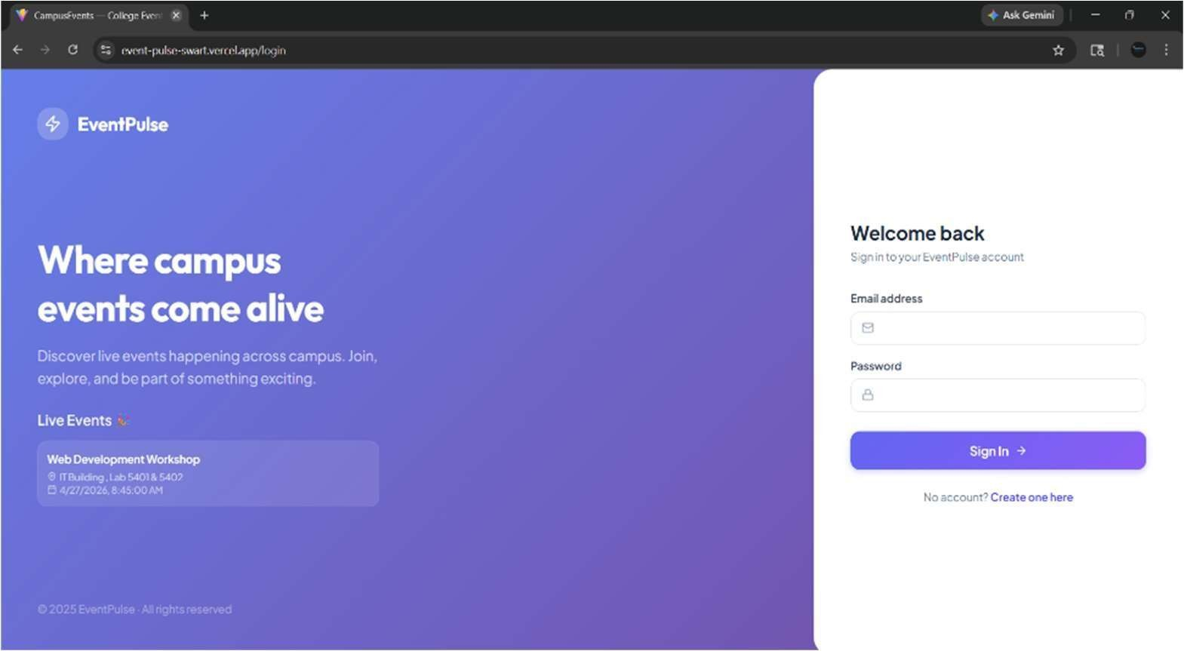

- Dashboard
The dashboard provides a role-based view showing relevant information such as events, approvals, and analytics.

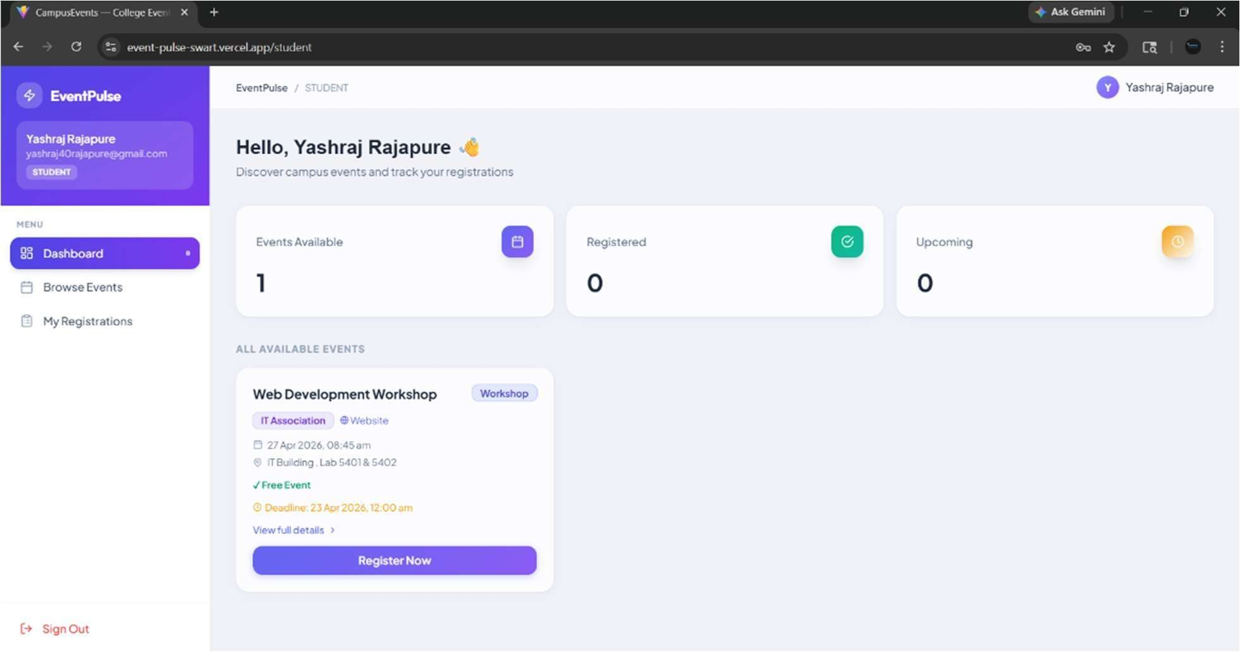

- Event Creation Page
Organizers can create new events by filling out event details, budget, and scheduling information.

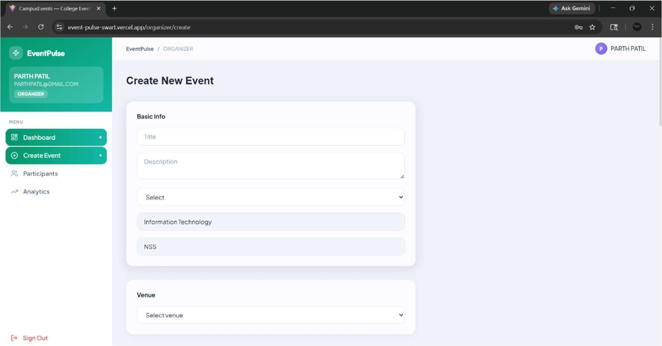

- Approval Workflow
This screen shows the multi-stage approval process involving Faculty, SDW, and HoD, with clear status indicators.

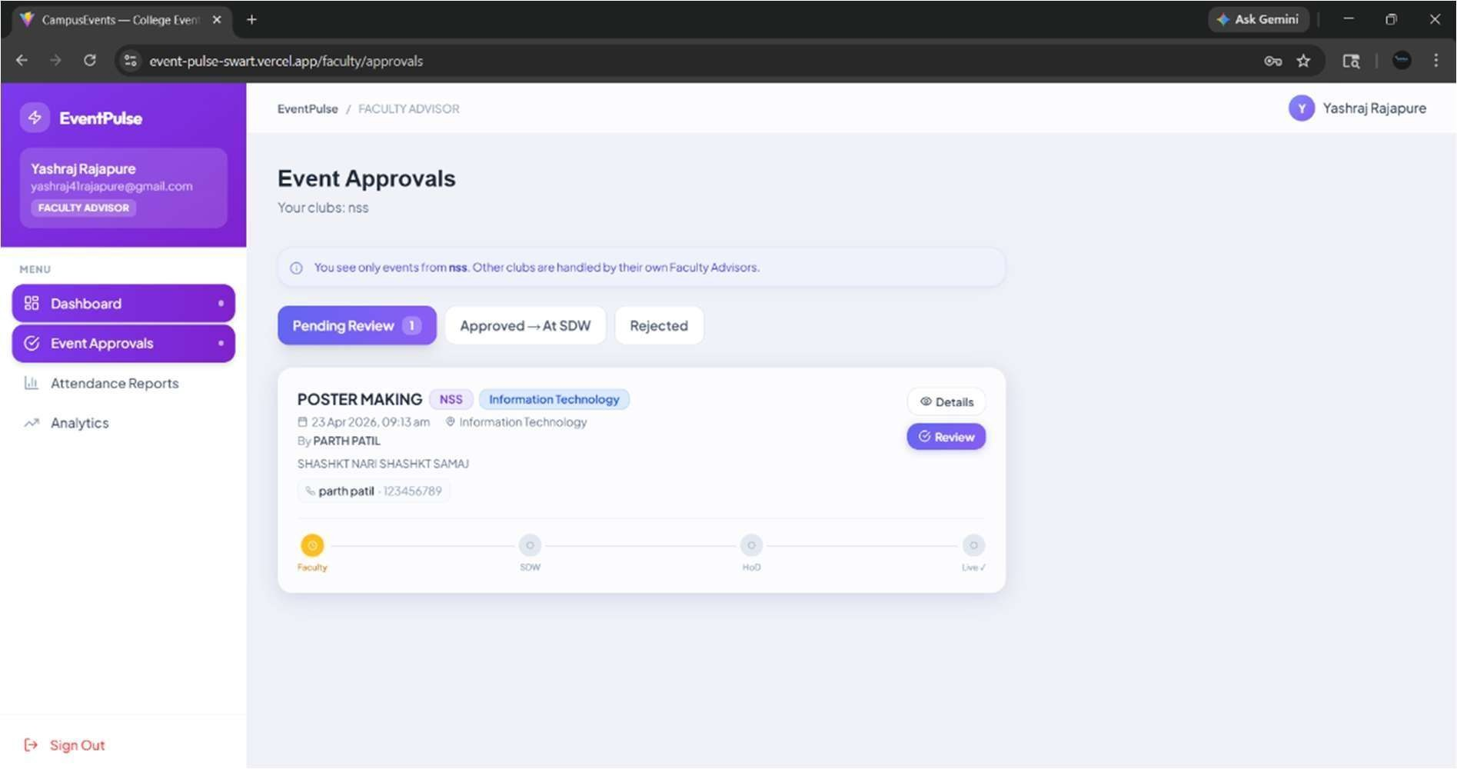

- Analytics Dashboard
The analytics section displays charts and graphs representing event trends, approvals, and department-wise data.

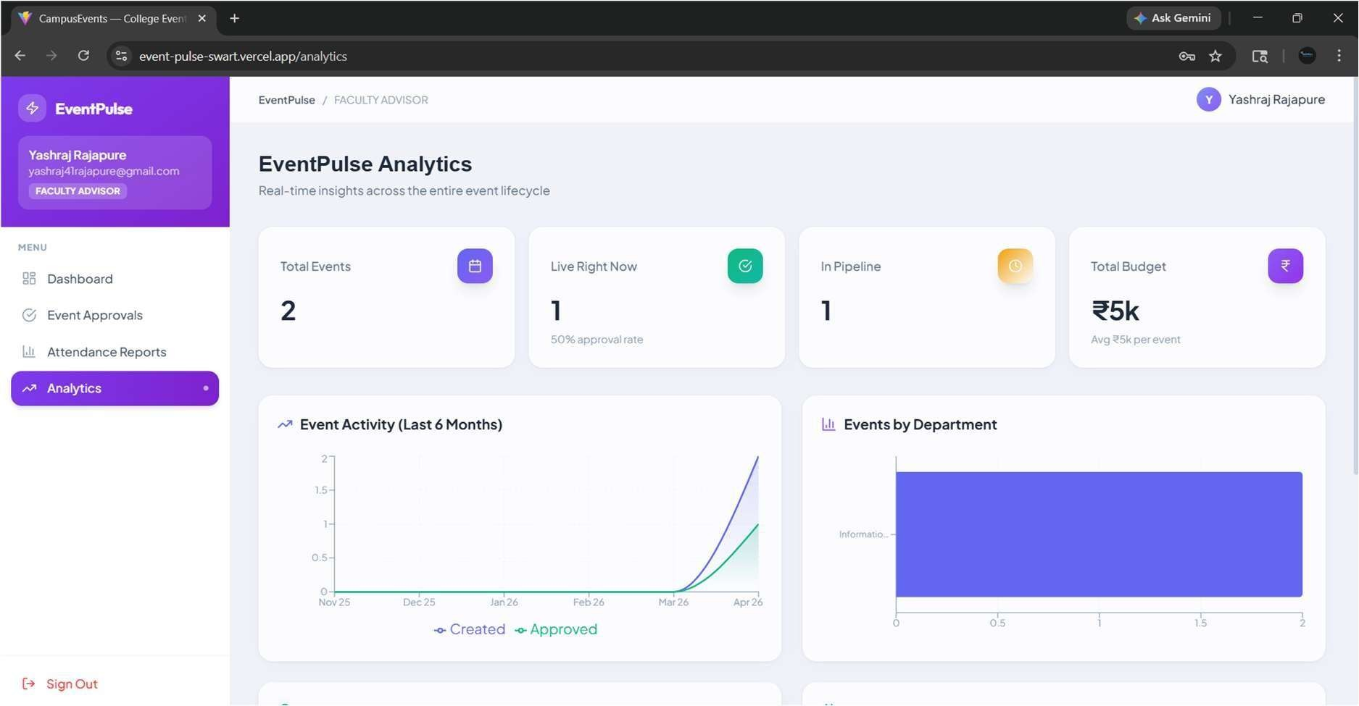

8.3 Discussion
The system effectively addresses the limitations of traditional event management systems by providing a centralized and automated platform. The role-based access control ensures security and proper authorization, while the state machine workflow guarantees structured approvals.
The integration of an analytics dashboard adds significant value by providing insights into event performance and participation trends. The responsive user interface ensures accessibility across multiple devices.
Overall, EventPulse improves:
    - Efficiency by reducing manual effort
    - Transparency through clear workflow tracking
    - Scalability by supporting multiple users and roles

8.4 Limitations and Future Enhancements
Although the system performs effectively, some improvements can be made:
    - Implementation of email notifications for approvals and updates
    - Enhanced security using HttpOnly cookies instead of local storage
    - Integration with cloud storage for file uploads
    - Addition of real-time notifications
These enhancements can further improve the system’s usability and scalability.

9.Conclusion
EventPulse is a comprehensive and efficient solution designed to modernize and streamline campus event management. The system successfully replaces traditional manual processes with a fully digital, automated workflow, ensuring improved efficiency, transparency, and reliability.
The project demonstrates strong full-stack development capabilities, integrating a React-based frontend with a Spring Boot backend and PostgreSQL database. Key features such as JWTbased authentication, role-based access control (RBAC), and a state machine-driven approval workflow ensure that the system is both secure and well-structured.
The implementation of a multi-level approval process involving Faculty, SDW Coordinator, and Head of Department ensures proper validation and governance of events. Additionally, the inclusion of an analytics dashboard provides valuable insights into event trends, approvals, and participation, enhancing decision-making capabilities.
The system is scalable and adaptable, making it suitable not only for academic purposes but also for real-world institutional use. It ensures smooth interaction between different stakeholders while maintaining data integrity and security.
Future Scope
The system can be further enhanced with the following features:
- Integration of email and notification systems for real-time updates
- Use of HttpOnly cookies for improved security
- Integration with cloud storage (AWS S3 / Supabase Storage) for file uploads
- Implementation of real-time notifications using WebSockets
- Advanced analytics with more detailed reporting
Overall, EventPulse demonstrates a complete and practical implementation of modern web technologies, making it a robust solution for campus event management.

10.References
The following resources were used during the development of the EventPulse system:
- React Official Documentation https://react.dev/
- Spring Boot Documentation https://spring.io/projects/spring-boot
- PostgreSQL Documentation https://www.postgresql.org/docs/
- JWT (JSON Web Token) Documentation https://jwt.io/introduction
- Tailwind CSS Documentation https://tailwindcss.com/docs
- Axios Documentation https://axios-http.com/docs/intro
These references provided guidance for frontend development, backend implementation, database management, and authentication mechanisms.

